A new feature in Moodle 2.3 is Drag and Drop. Below you will see how this feature works. NOTE: You cannot use Internet Explorer (IE) with this feature, but Firefox and Chrome work well.
- Find the file you would like to submit (the highlighted files show the file selected to upload). Click the file, and drag it to the “files” area and drop. It’s that simple.
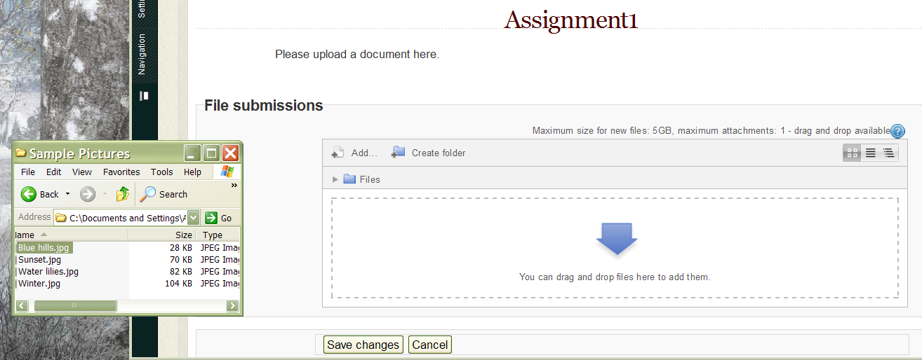
- This picture below shows the file has that has been dropped. Click the “save changes” button for submission.
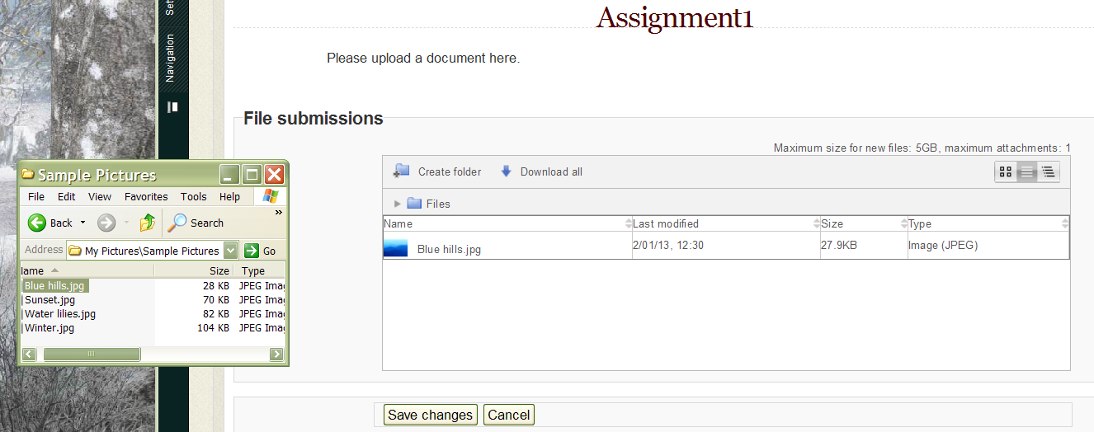

Note: Moodle 2.3 drop and drag feature will not work in Internet Explorer. If you see this (swirling circle), you are in IE. Log out and switch to Firefox or Chrome.
