Brunswick Community College

February 2017
Handouts

BRUNSWICK COMMUNITY COLLEGE EMERGENCY ACTION PLAN

INTRODUCTION

EVACUATION

RESPONSIBILITIES

NOTIFICATION

ASSEMBLY POINTS FOR EVACUEES

If a building evacuation is necessary, employees and students shall be evacuated to the locations listed below.

Building Address Assembly Location Address
A  Administration | 50 College Rd NE | Odell Williamson Aud.  Rear lot | 150 College Rd NE
B  Math/Science | 110 College Rd NE | Odell Williamson Aud.  Rear lot | 150 College Rd NE
C  Early College High School  Con-Ed/GED  Cosmetology | 60 College Rd NE | Odell Williamson Aud.  Rear lot | 150 College Rd NE
D  Business | 40 College Rd NE | Odell Williamson Aud.  Rear lot | 150 College Rd NE
E  Brunswick Interagency Program | 30 College Rd NE | G Building (Maint.)  Rear Lot | 40 College Rd NE
F  Brunswick Interagency Program Lunch Room | 30 College Rd NE | G Building (Maint.)  Rear Lot | 40 College Rd NE
G  Maintenance | 10 College Rd NE | G Building (Maint.)  Rear Lot | 40 College Rd NE
H  Aquaculture | 199 College Rd NE | Odell Williamson Aud.  Rear Lot | 150 College Rd NE
I  Old Church | 1277 Old Ocean Hwy | Odell Williamson Aud.  Rear Lot | 150 College Rd NE
J | 115 College Rd NE | Odell Williamson Aud.  Rear Lot | 150 College Rd NE
K  Applied Plant Science | 185 College Rd NE | Odell Williamson Aud.  Rear Lot | 150 College Rd NE
L  Athletics/Aquatics | 210 College Rd NE | Odell Williamson Aud.  Rear Lot | 150 College Rd NE
Odell Williamson Aud. | 150 College Rd NE | Odell Williamson Aud.  Rear Lot | 150 College Rd NE
Leland Campus | 2045 Enterprise Dr. Leland | Victaulic (across street)  Rear Lot | 2010 Enterprise Dr.  Leland
South Brunswick Islands Center | 9400 Ocean Hwy | Grass Area near Hwy 17  at Main Entrance | 9400 Ocean Hwy
Brunswick Educational Transitional Center (BETC) | 104 Ocean Hwy E, Supply | Supply Baptist Church  Rear Lot | 88 Ocean Hwy E  Supply
Southport Center | 705 North Lord St,  Southport | Vacant Lot  to right, across street | Corner of North Lord St and W. Owens St

MEDICAL AND FIRST AID

In the event of a serious injury or illness on campus, immediately dial 911. Give your name; describe the nature and severity of the medical problem and the campus location of the victim. Send someone to meet and direct the Emergency Medical Services (EMS) unit to the scene.

In cases of injury or illness, administer first aid to the best of your ability until trained personnel arrive on scene.

AUTOMATED EXTERNAL DEFIBRILLATION (AED)

Employees are advised that, should such an emergency occur in your presence, help may be obtained by dialing 911 for the Brunswick County EMS. AED’s are located at buildings A, C, L, OWA, SBIC and Leland campuses. (See list below)

Building | Address | Name
A | 50 College Rd | Police Office
C | 60 College RD | Admin Office Early College High School
L | 210 College RD | Pool Area
 |  | Front Desk
OWA | 150 College Rd | Wall near Women’s restroom in lobby
SBIC | 9400 Ocean Hwy | Right of bar at event center
Leland | 2045 Enterprise Dr. | Wall near elevator 1st floor

PSYCHOLOGICAL CRISIS

A psychological crisis exists when an individual is threatening harm to themselves or to others, or is out of touch with reality due to severe drug reactions or a psychotic break. A psychotic break may be manifested by hallucinations or uncontrollable behavior.

Keep in mind that individuals taking prescription medications and those needing insulin, as well as individuals using illegal drugs, may appear disoriented or irrational. Report any individuals who seem to have no legitimate reason to be on the college campus.

If a psychological crisis occurs:

- Never try to handle a situation on your own if you feel it is dangerous.

- Call 911.

- Clearly state that you need immediate assistance, give your name, location, and the area involved.

The BCC Police Officers have received training in this area and the legalities of involuntary commitment to psychological or psychiatric treatment. They may also summon outside assistance if there is a need to do so.

SUSPICIOUS BEHAVIOR

Crisis on campus can be the result of violent, disruptive, or criminal behavior. Everyone is asked to assist in making our college a safe place by being alert to suspicious situations or persons and promptly reporting them to BCC Police. This would include but not limited to suspicious or threatening behavior, suicidal tendencies, severe mood changes among fellow students, e-mails/web-blogs/texts that you may have received or seen, papers that have been turned in or any behavior you feel may be a threat or a security issue for you, others, or the institution.

- For emergencies dial 911.

- For non-emergencies contact the BCC Police Department by dialing 755-7330 (7330 from a college phone.

Be sure to give the following information:

- Nature of the incident

- Location of the incident

- Description of person(s) involved

- Type of weapon (if any), i.e. handgun, shotgun, rifle, etc.

- Actions of suspicious person(s)

VIOLENT OR CRIMINAL BEHAVIOR

Everyone is asked to assist in making the campus a safe place by being alert to suspicious situations and promptly reporting them.

If you are a victim or a witness to any on-campus offense, or if you observe a suspicious person on campus, AVOID RISKS! Promptly call the BCC police by dialing 911 and report the incident, including the following:

- Nature of the incident

- Location of the incident

- Description of the person(s) involved

- Description of the property involved

Assist law enforcement officers on their arrival by supplying them with requested additional information and ask others to cooperate. In the event of gunfire or explosion, take cover immediately using all available concealment. After the disturbance, seek emergency first aid if necessary.

ACTIVE SHOOTER/HOSTILE INTRUDER

When an active shooter in a campus building is actively causing harm or threatening imminent deadly harm to people, you must immediately seek cover, shelter in place and call 911. Give as many details as possible: your name, location, number of assailants and other pertinent information.

- Do not sound the fire alarm to evacuate the building.

- Be aware of alternate exits if it becomes necessary to flee.

- People should lock themselves in classrooms, labs, and offices as a means of protection. If the door will not lock, try barricading the door with desks and chairs. Lie on the floor and/or under desks and remain silent.

- Cell phones should be set on silent mode so that the suspected shooter cannot hear them. Use the phone to notify 911, let them know that you have heard gunfire, give them your location and the number of the cell phone that you are calling from.

- If possible, close blinds of any windows or openings that have a direct line of sight into the hallway.

- Students and staff should not attempt to leave the building until told to do so by the BCC emergency personnel.

- When you encounter the police, keep your hands over your head and comply with the officers instructions. If you are evacuating, carry nothing that could be mistaken as a weapon.

- Do not speak with the media following the incident until cleared to do so by the President or their designee.

When an active shooter is actively causing deadly harm or the threat of imminent deadly harm to people on campus grounds, you must immediately seek cover, shelter in place and call 911. Give as many details as possible your name, location, number of assailants and other pertinent information.

- Run away from the threat if you can, as fast as you can.

- If you get away from the immediate area of danger, report the incident by calling 911.

- If you decide to hide, take into consideration the area in which you are hiding. Will you be found? Can you lock yourself in as a means of protection?

- If the person is causing death or serious injury to others and you are unable to run or hide, you may choose to overcome the suspect with force as a last resort that should only be considered in the most extreme circumstances. Only you can decide if this is something you should do. Remember there may be more than one shooter.

If an active shooter is actively causing deadly harm or the threat of imminent deadly harm to people outside of your building, you must immediately seek cover, shelter in place and call 911. Give as many details as possible your name, location, number of assailants and other pertinent information.

- Turn off all the lights, close and lock all windows and doors. If you cannot lock the door, try to block the door with desks and chairs.

- If you can do so safely, get all occupants on the floor and out of the line of fire.

- If you can do so safely, move to the safe area of the building and remain there until police tell you it is safe to leave. Do not respond to commands until you are certain they are issued by a police officer.

When an active shooter enters your office or classroom:

- If possible, call 911. If you can’t speak, leave the phone line open so the Brunswick County Emergency Services dispatchers can hear what is being said.

- If you are hiding and unable to flee, attempts to negotiate with the suspect may be successful.

- Attempting to overcome the suspect with force is a last resort that should only be considered in the most extreme circumstances. Only you can decide if this is something you should do. Remember there may be more than one shooter.

- If the shooter exits your area and you are able to escape, leave the area immediately. Do not touch anything in the area and remember to be alert for responding officials who may mistake you as the shooter.

- While escaping, as soon as you see an officer put your hands over your head and immediately comply with the officers instructions.

LOCKDOWN

- LEVEL ONE – Complete and total lockdown of all students and faculty/staff personnel. All students and employees should stay inside classrooms/offices and keep all doors locked. No one should come or go until an “all clear” has been given.

- BIP– All students will be kept inside classrooms and all doors will be locked. No one should come or go until an “all clear” has been given. (Example of BIP LOCKDOWN may be a suspicious person, vehicle or upset parents in or near the building.) This will only apply to the Brunswick Interagency Program, BIP, 30 College Rd.

- All classrooms and offices will receive an alert tone/message through the phone system.

  - Get students out of hallways and into classrooms
  - Secure classroom doors (should remain in a locked position at all times)
  - Windows should be locked and blinds closed
  - Get students out of sight
  - Turn lights out
  - Account for all students
  - Keep quiet (silence electronics/do not use phones unless relaying critical information)

TORNADO

You can greatly reduce the chance of injury by doing a few simple things:

- SECONDS COUNT!!! If it takes more than 2 or 3 minutes to move all upper floor people down, the risk of injury increases significantly.

- If a tornado “watch” is issued for your area, it means that a tornado is “possible”.

- If a tornado “warning” is issued for your area, it means that a tornado has actually been spotted, or is strongly indicated on radar, and it is time to go to a safe shelter immediately.

- Weather is monitored on campus during impending severe conditions. It is imperative that staff and faculty assist by directing students and visitors to safe areas.

- Be alert to what is happening outside. The following danger signs may be an indication that a tornado is imminent:

- A greenish or greenish/black color to the sky

- If there is watch or warning posted, then the fall of hail should be considered a real danger sign.
- A strange quiet that occurs within or shortly after a thunderstorm.

- Clouds moving by very fast, especially in a rotating pattern or converging toward one area of sky.

- A sound of a waterfall or rushing air at first, but turning into a roar as it comes closer. The sound of a tornado has been likened to that of both railroad trains and jets.

- Debris dropping from the sky.

- An obvious “funnel-shaped” cloud that is rotating or debris such as branches or leaves being pulled upwards.
- Move to the interior area of the lowest floor possible.

- Put as many walls as possible between yourself and the tornado.

- Crouch as low as possible with head down, protecting the back of the head with the arms.

- Stay away from large open rooms such as auditoriums, cafeterias, and lounges.

- If in a car, abandon it immediately and go to a substantial structure or lie flat in the nearest ditch or depression and use your hands to cover your head.

FIRE

In the event of a fire you should do the following:

- Know the location of a fire extinguisher, fire exits, and alarm systems in your area and know how to use them.

- In case of fire or smoke, call 911. Use a fire extinguisher when possible and if it can be done safely. Direct the charge of the fire extinguisher toward the base of the flame. Never attempt to fight a fire larger than the size of a wastebasket.

- If an emergency exists, find the nearest fire alarm pull station and activate alarm.
- Close all windows and turn off gas-burning equipment.

- Evacuate all rooms, and close all doors to confine the fire and reduce oxygen.

- Walk quickly to the nearest “SAFE EXIT” and ask others to do the same. Assist the disabled in exiting the building. DO NOT USE ELEVATORS.

- Once outside, move quickly to the fire evacuation area for your building. Keep streets and walkways clear for emergency vehicles and crews.

FIRE DRILLS

Brunswick Community College is committed to the safety and security of all students, employees and visitors while on campus.

Students and employees should not leave campus during a fire drill. Once your group has reached the assembly point, remain with the group. Supervisors and instructors are to account for individuals in their respective classes and areas.

As soon as the “ALL CLEAR” has been given you may return to your buildings.
BUILDING EVACUATIONS
Assembly Points for
Buildings A, B, C and D
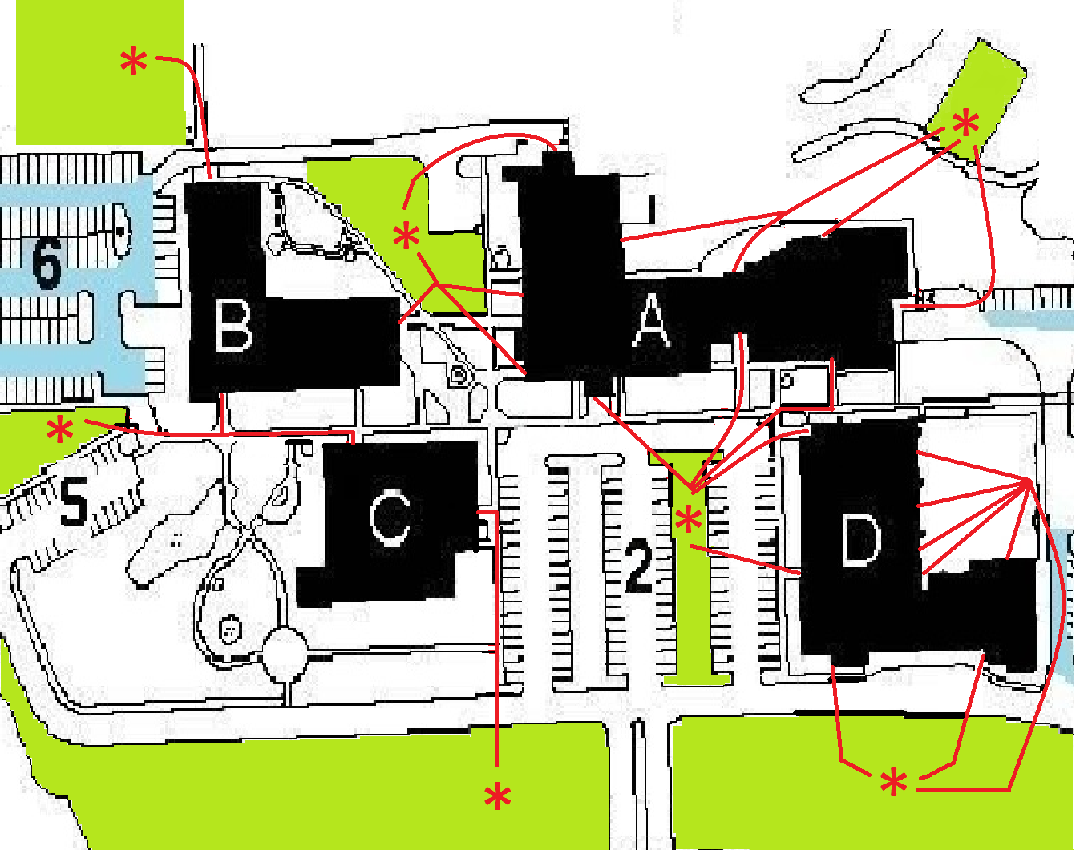

Exit Area Assembly location
Building A
Business Office/Print shop | Grassy area near garden at B building
Front/Student Center/Bookstore | Grassy area in Parking Lot 2
ECHS Café/ Student Center/Cafeteria | Old basketball court

Building B
Side nearest Odell Williamson Auditorium | Grassy area at Odell Williamson Auditorium
Front | Grassy area near garden at B building
Side nearest C building | Grassy area between Parking Lots 5 & 6

Building C
Front | Wooded area across College Rd
Side nearest B building | Grassy area between Parking Lots 5 & 6

(McLamb) Building D
Side nearest College RD | Wooded area across College Rd
Front/Side near A building | Grassy area in Parking Lot 2
Back | Wooded area across College Rd
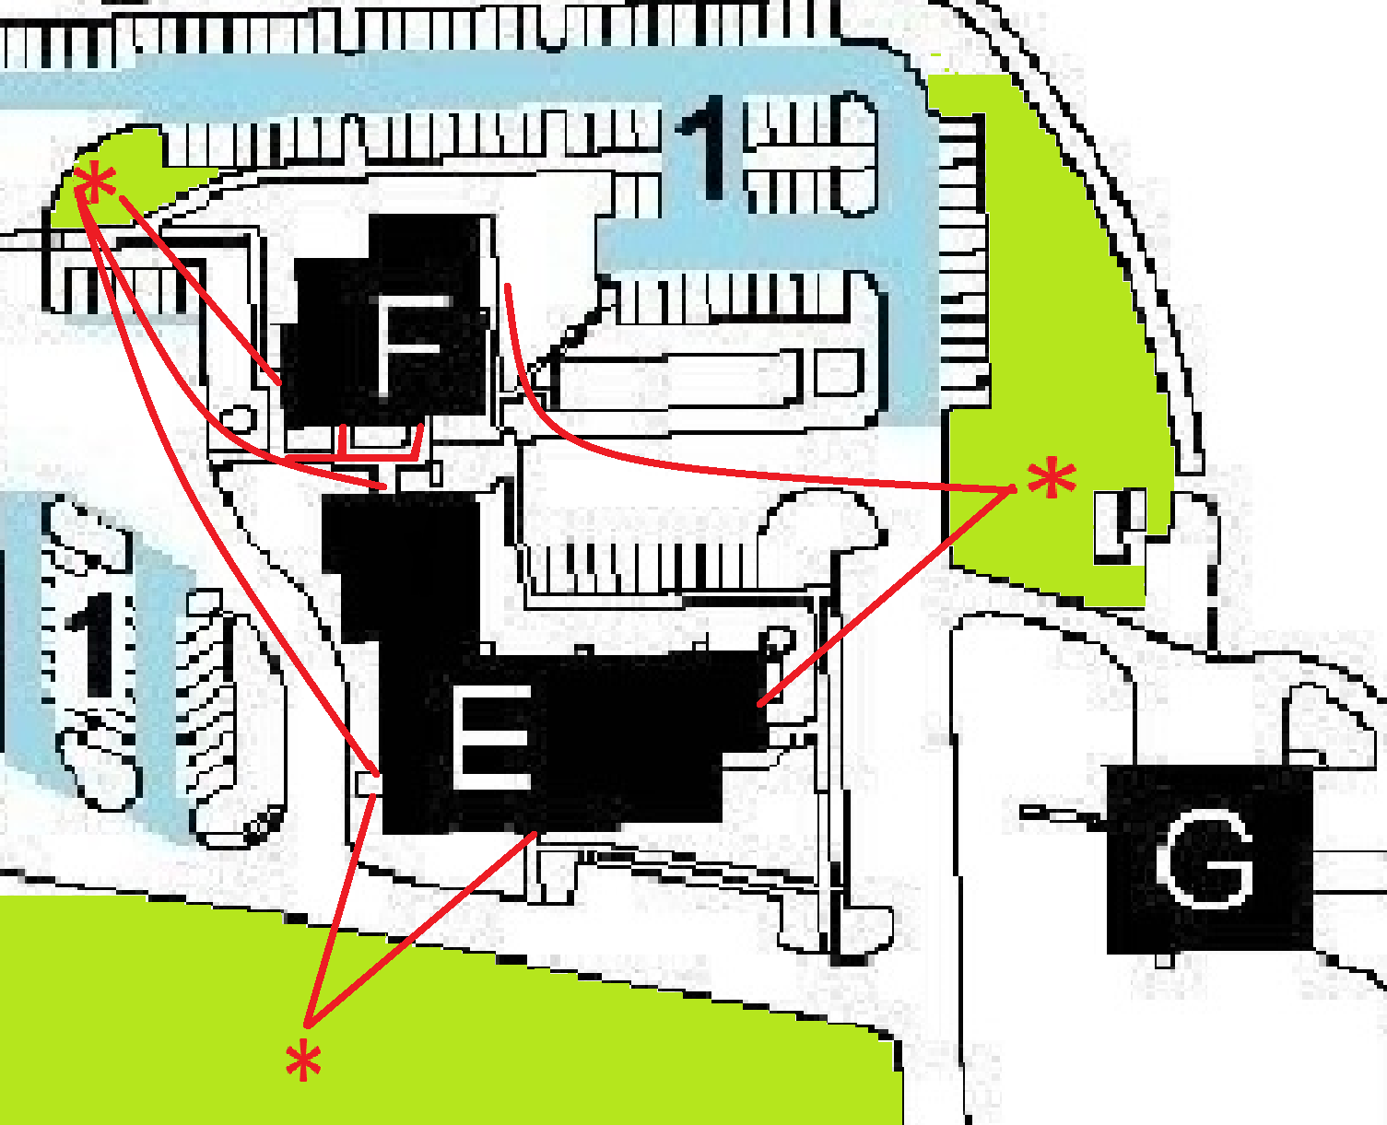

E (BIP) & F (Lunchroom)
Front E | Wooded area across College Rd
Side E/Back E/Front F/Side F- nearest Parking Lot 1 | Grassy area at Parking Lot 1
Side E&F facing Maintenance. | Grassy area across parking lot near generator

Building G
All exits | Grassy area across parking lot near generator

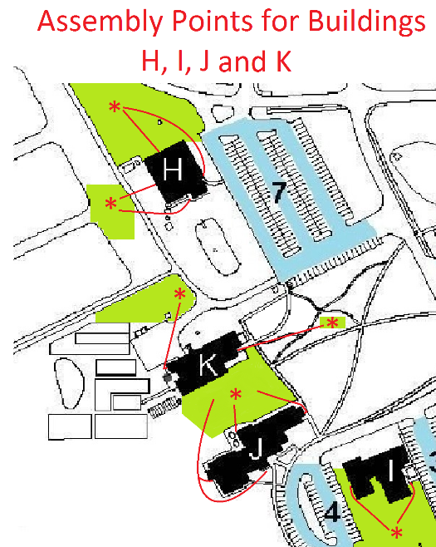

Building H
Front/Side facing L Building | Grassy area directly from Side Door
Back/Side facing K Building | Pond Area

Building I
All exits | Grassy area near Old Ocean Hwy

Building J
All Childcare classrooms | Grassy area between J & K
Regular classroom/Offices | Grassy area between J & K

Building K
Bays/Back | Pond Area
Front | Wooded area

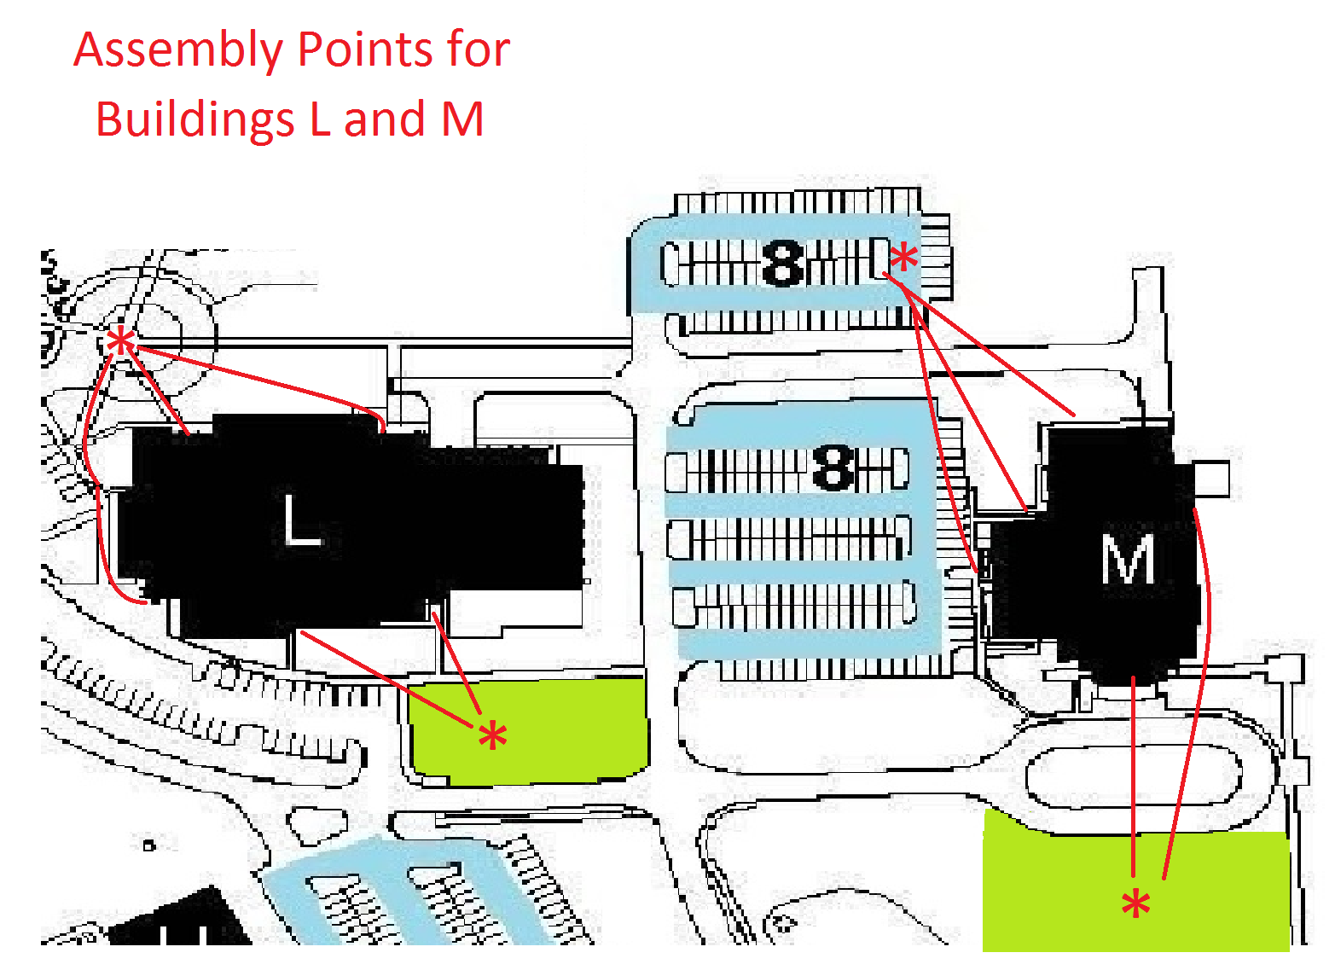

Dinah E Gore
Backside/Front/Gym | Circle at Baseball Field
Side facing Parking Lot 7/Pool | Grassy area nearest Odell Williamson Aud.

Odell Williamson Auditorium
Front/Side facing woods | Grassy area past OWA circle
All other Exits | Back Parking Lot at OWA

Brunswick Education Transitional Center
All Exits | Supply Baptist Church rear lot

Leland Center
All Exits | BLET Training Area across parking lot

South Brunswick Island Center
All Exits | Grassy Area near main entrance

Southport Center
All Exits | Open field across from the main entrance

